**Seed Corn Plantability Guidelines**

Excellent planting accuracy and stands can be achieved using all seed sizes with appropriate planter adjustments and calibration. These plantability guidelines are designed to provide management tips that will help growers optimize planter performance and precise planting accuracy with seed of all sizes.

**Batch-Specific Plantability Information**

For the most precise recommendations, you can directly access information for individual seed batch numbers and your specific planter type at CURRY CORNER ON OUR WEB SITE*.* The batch number for the corn hybrid is located on the bag tag (example highlighted below).

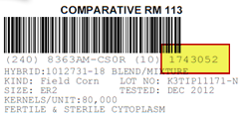

**Seed Lubricants**

All CURRY COAT SEED TREATMENT utilize polymer coatings for improved seed flow and plantability while reducing dust-off. Many planter manufacturers recommend adding talc or graphite to the seed to improve plantability. The polymers used as part of seed treatments by CURRY are not intended as a substitute. Refer to planter manufacturer owner’s manual for complete recommendations on proper use of seed lubricants.

Fluency Agent from Bayer Crop Science is available as an alternative for talc, graphite and talc/graphite blended planter seed lubricants. Fluency Agent helps reduce the amount of total dust and further minimizes the amount of active ingredient potentially released in treated seed dust during planting. Add Fluency Agent at the rate of 1/8 cup per 80,000-kernel unit of seed or 4 3/8 cups per 35 bushels. IMPORTANT: Mix the Fluency Agent thoroughly into the seed. When filling large central fill seed hoppers, add the Fluency Agent to seed as it is filling the hopper to assure even distribution. DO NOT USE MORE THAN 1/8 CUP PER SEED UNIT! Fluency Agent can be used in all makes and types of planting equipment that recommend the use of a planter seed lubricant.

**Bulk Planter Systems**

Delivery of seed from center-fill hopper to meter may be impacted by several factors. These include planting time, atmospheric environment, use of planter lubricant, ground speed, level of treatment, and seed size. The liberal use of talc, graphite, or a talc-graphite blend, specific by planter type, is critical. Thorough mixing of these lubricants in seed generally produces the best results. High population settings, combined with high ground speed may create challenges. If meters are “starving” for seed, reduced ground speed may provide a solution. The proper fan speed or pressure in the bulk delivery system is an adjustment that can be made to enhance seed delivery. This varies by planter manufacturer. Consult the planter operator’s manual for proper setting. Larger seed, especially with high-rate treatment, can be delivered to the meter and planted accurately if consideration is given to the points above.

**Summary of Seed Lubricant Guidelines by Planter Manufacturer*   
  
Kinze and John Deere finger-type planters –** When planting treated seed, use your planter manufacturer’s recommended amounts of dry powdered graphite. To ensure good seed coverage, add graphite at several levels as the hopper is filled, rather than only on the top.   
  
**John Deere vacuum-type including ProMAX40 flat disk** – Talc lubricant is required for optimum performance of the vacuum meter and CCS system (if equipped). Add talc at the rate of 2.5 ounces per 80,000-kernel unit of seed or 11 cups per 35 bushels or 16 cups per 50-bushel fill. Adjust these rates as necessary so all seeds become coated with talc, while avoiding an accumulation of talc in the bottom of tank or hopper. Double the talc recommendation when planting small seed, large seed, seeds with heavy treatment, or in humid planting conditions. If seed treatment is building up on the disc, use additional talc. Add talc throughout the box while filling, not just on top.   
  
**Precision Planting e-Set® disk** – Use 1/4 cup of the company’s eFlow seed lubricant (or an 80% talc/20% graphite mix) per 80,000-kernel bag. Heavily treated seed may require a higher rate.

**Kinze EdgeVac® vacuum planter** – Manufacturer recommends mixing 1 tablespoon of powdered graphite into each hopper-fill of seed. Mix thoroughly so all kernels are coated. Adjust graphite rate as needed. Planting in high humidity conditions may require use of talc as a drying agent.

**Kinze Air Seed Delivery (ASD) system** – Powdered graphite should be added with the seed each time the bulk seed hopper is filled. Use 1½ - 2 pounds per 50 units of seed. Graphite should be added in layers as the bulk seed hoppers are filled. Use of powdered graphite will prolong the life of the seed meter components, reduce buildup of seed treatment on components in the meter and improve seed spacing.

**White** – Manufacturer recommends mixing 1/2 cup of talc per two-bushel hopper fill, or 1 cup of talc per three-bushel hopper fill. Seed treatments may also affect seed monitor performance and require periodic cleaning of the seed disc.

**Case IH vacuum Advanced Seed Meter (ASM)** – Graphite is recommended for lubrication. Talc is not recommended as a sole lubricant for the Advanced Seed Meter, though it may be added to graphite to improve flow in bulk delivery of seed.

On-Row Hopper: Case IH recommends 1/8 cup of graphite per row-unit hopper.

Bulk Fill System: Case IH recommends 1/8 cup of graphite per two units of seed as a starting point for most seed sizes and treatments. Some seed sizes and treatments may require additional lubrication to flow into the delivery system in high humidity conditions. In such situations, a 50-50 blend of talc and graphite is acceptable within the system.

*Refer to individual planter manufacturer owner’s manual for complete recommendations.

**Optimizing Performance of John Deere Vacuum Planters**

* The manufacturer’s recommended maximum operating speed is 38 disk RPMs.
* This planter uses vacuum rather than air pressure to hold the seed against the disks.
* Three disks are available: regular, small, and ProMAX40. The standard corn disk (A50617) will accurately plant seed sizes up to approximately 2,000 seeds per pound. The small disk (A43215) is designed for small seed – usually greater than 2,000 seeds per pound. The ProMAX40 disk (A52391) is designed to plant all seed sizes.
* The ProMAX disk may under-populate if vacuum is too low. Set at higher vacuum levels, the ProMAX disk is much more tolerant because the doubles eliminator prevents over-population.
* Vacuum levels taken from charts are a starting point. However, high-rate seed treatment, uneven ground conditions and/or faster ground speeds require higher levels of vacuum than indicated. Perform a field check and adjust level to obtain proper population.
* John Deere also recommends adding talc to improve seed singulation and spacing of all treated seed.

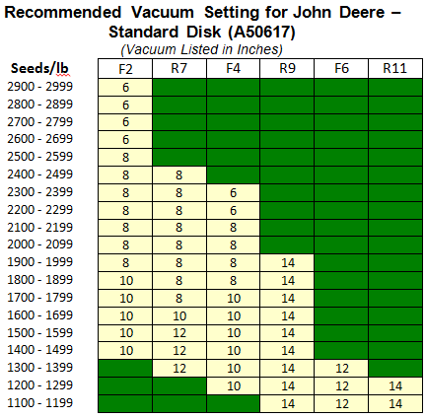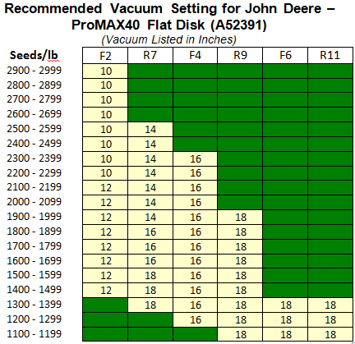

* 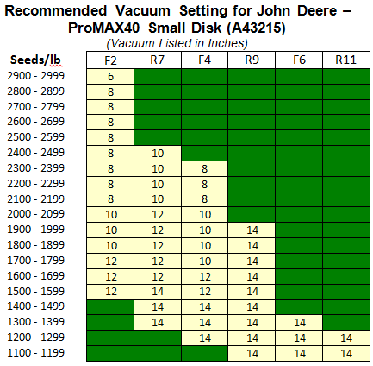**ProMAX40 disk (**A52391): F2, R7, F4, R11, R9
* **Standard disk** (A50617): F2, R7, F4, R11, R9
* **Small disk** (A43215): F2, R7, F4, R9

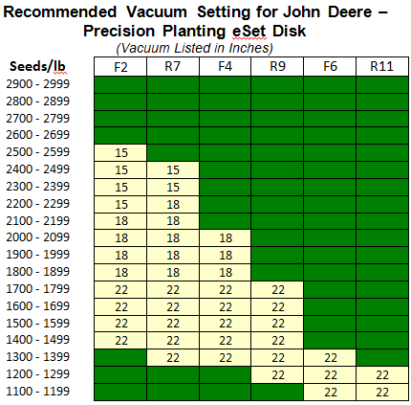**Tips When Using Precision Planting eSet Disk**

* One disk plants all seed sizes.
* Most seed plants at 15” or 18” of vacuum.
* Very large seed may benefit from additional vacuum – up to 22”.
* Precision Planting recommends use of their e-Flow™ lubricant, a mix of talc and graphite.

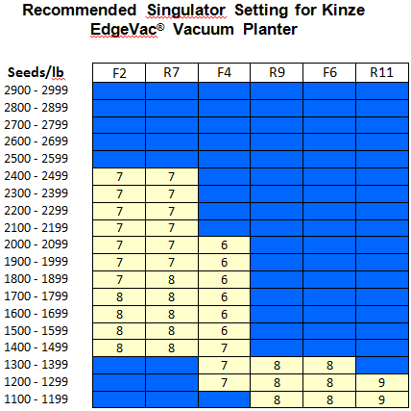**Optimizing Performance of Kinze EdgeVac® Vacuum Planter**

* Two are available for the EdgeVac® meter:
  + 39-cell disk (light blue in color)
  + 24-cell low-rate disk (light green in color)
* Both will plant seed sizes in the range of 35 to 70 lbs. per 80,000-kernel bag (2,286 to 1,143 seeds per lb.).
* For most kernel sizes, set vacuum at 18”. For larger, heavier seed, set at 20” for best plantability. Incrementally increase the vacuum level to improve accuracy as needed on larger, more heavily treated seed.
* Singulator brush settings on this planter range from 1 (least aggressive) to 11 (most aggressive). Manufacturer recommends a range of 5-7 for corn. DuPont lab testing suggests a setting of 8 or 9 may improve accuracy for larger seed.

**Optimizing Performance of Kinze Model 3600 Vacuum Planter**

*Refer to manufacturer’s vacuum settings at www.kinze.com

**Optimizing Performance of Kinze/John Deere Finger Planters**

* The manufacturer’s recommended maximum operating speed is 75 finger RPMs. This corresponds to the maximum suggested ground speed for most sprocket combinations. Ground speed will vary depending on the sprocket combination being used.
* Proper finger and spring tension is important.
* John Deere factory specifications are that fingers should be set at 23 to 25 inch lbs. Consult owner’s manual for adjustment procedure.
* Kinze factory specifications are 22 to 25 inch lbs. of rolling torque. Consult owner’s manual for adjustment procedure.
* Worn parts should be replaced. Worn brushes can cause up to 15 percent overplant, especially when using smaller kernel sizes. Grooves worn into the faceplate also can cause overplanting.

**Finger mechanism planter meter:** Finger mechanism planter meters can accurately plant a wide range of kernel sizes. Finger tension adjustment for large seed sizes such as R11, and small kernel sizes such as F2 seed may improve drop accuracy. Individual meter calibration, using the actual seed size to be planted, can significantly improve the spacing accuracy of this finger mechanism meter. Increasing field speed increases seed drop on these planter units.

Always check actual field populations to ensure desired accuracy. If desired drop is not achieved, consider the following options:

* Well-maintained planter units experience less variance. Have a qualified technician check planter unit condition and adjustment. Proper calibration using the actual seed size to be planted will help minimize this problem.
* Move sprocket combination up one setting. Population drop will increase by approximately 3%. Consult manufacturer operator’s operation manual.
* Seed coated thoroughly with graphite will provide potential increase in seed drop of 1-2%.
* Plant within the manufacturer’s recommended speed range.

**Precision Planting Finger-Type Precision Meter**

DuPont has not tested plantability of the precision meter from Precision Planting because it is assumed these units will be custom calibrated by trained MeterMax® technician. If all seed being planted is large (R9 or R11), Precision Planting makes shims that may be placed under the cam to increase the opening height of the fingers. The standard finger configuration will do an adequate job on large seeds, and is preferred if planting a variety of small, medium and large seed sizes.

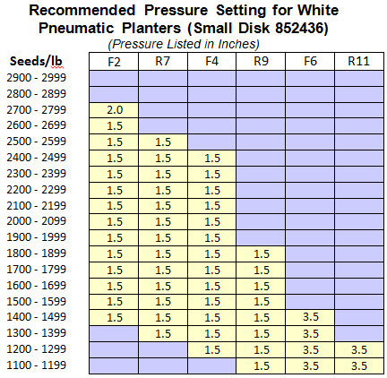

**Optimizing Performance of White Planters**

* The manufacturer recommends a disk speed of 32 RPMs with suggested disk and air pressure. Adjustments to air pressure can be made depending upon the disk used and the kernel size being planted. Smaller seeds usually require less air pressure.
* Air pressure can be adjusted from 1.0 to 5.0 inches of water. The percentage of skips or doubles is managed with increases or decreases in air pressure.
* The manufacturer does not recommend the use of talc with the seed unless seed coatings interfere with metering.
* **A disk (700745799) is now available for planting F2, F4 and F6 flat seed sizes, 1200 to 2200 seeds/lb.**

**Optimizing Performance of Case IH 1200 Series ASM Planters**

* 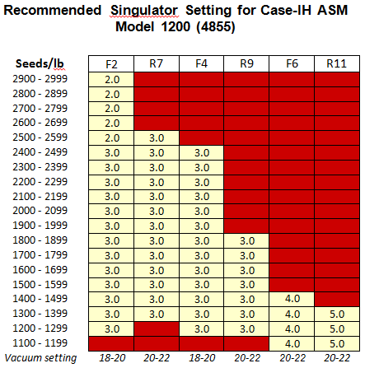Manufacturer vacuum range for corn planting is 18-22 inches of water vacuum.
* Seed disk number indicates number of holes and hole diameter. For example, seed disk 4855 contains 48 holes with each hole 5.5 mm in diameter.
* Vacuum level is set by adjusting fan speed control with seed on disk. Setting is in inches of water (inches H20).
* Meter cover indicates baffle setting number. Meter inspection without draining seed can be made when baffle is set to position 0 (fully closed).
* Do not use singulator dial (lever) settings to control gross population; excessive doubles or skips will occur. Higher dial setting decreases singulator interference with seed disk holes.
* Testing indicates all kernel sizes can be planted accurately with this unit. Test results for most seed sizes average within +/- 1% of the expected drop with this equipment.
* Testing conducted at the DuPont Pioneer plantability laboratory suggest vacuum and singulator settings in the manufacturer’s owner’s manual should be considered as a starting point. Variations may be necessary to achieve optimum plantability, especially for larger and more heavily treated seed.
* Remember to change singulators back after each seed adjustment for larger seed.

**Case IH Planters Equipped with Precision Planting**

*Refer to precision planting recommendations at www.precisionplanting.com/#products/vset/

**Optimizing Performance of Case IH 800, 900, 950 & 955 Early Riser Planters**

* The manufacturer’s recommended maximum drum speed is 35 RPMs, with seed metered in a 36-hole drum. Air pressure should be set from 9 to 11 ounces.
* Plant all seed sizes except R11 and R9 using 9 ounces of pressure. Plant R11 and R9 seed sizes at 11 ounces of pressure.
* Adjust the brush to the down position for all seed sizes. For most seed, do not wire the brush down as is done for soybean planting. However, R11 and R9 seed are the exception and may plant best with the brush wired down.
* Replace the entire brush assembly when wear is apparent.





e-Set® and e-Flow™ are trademarks or registered trademarks of Precision Planting, Inc.

EdgeVac® is a registered trademark of Kinze Manufacturing, Inc.

All products are trademarks of their manfufacturer

Seed treatment services may be provided by independent contracted sales professionals. Not all sales professionals offer the services, and costs may vary. See your sales professional for details.

® ℠ ™Trademarks and service marks of DuPont, Pioneer or their respective owners. © 2016 PHII.